Weather App Using HTML, CSS, JavaScript

Weather app is used to predict the weather and analyse the changes to make predictions about weather conditions, This app displays the temperature and the type of weather on that particular date in your current location or you can also check the weather for different cities by giving the city name.

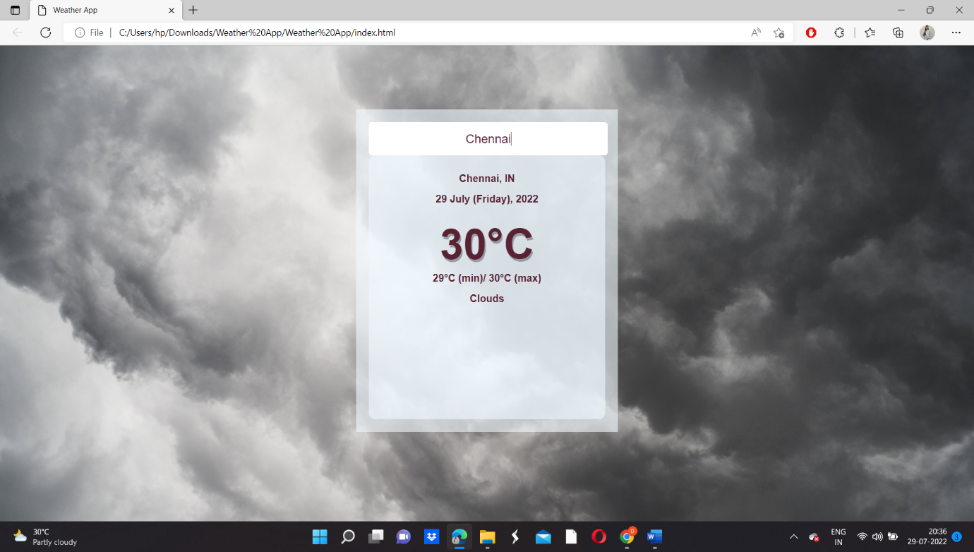

https://github.com/jahnavi258/Weather-App